Lernkontrolle II
Name
Lies den Sachtext über den Igel aufmerksam durch und entscheide dann, ob die Aussagen richtig oder falsch sind oder nicht im Text vorkommen.
The hedgehog
The hedgehog lives in gardens, parks or forests. During the day, it hides in a bush to sleep. At night it looks for food. Its favourite food is insects, but it also likes little frogs or worms. Sometimes it eats little birds’ eggs or wild berries.
In winter, a hedgehog sleeps. So during this long sleep it doesn’t eat. But it eats a lot of food in spring, summer and autumn.
To survive the winter cold the hedgehog sleeps in a warm pile of leaves. A hedgehog has up to 8000 prickly spines. These spines are all over its back, but not on its face or belly. Its spines help the hedgehog to protect itself from other animals. In case of danger the hedgehog rolls up into a ball. No animal will want to eat this prickly ball. However, the biggest danger for the hedgehog are cars. It is not a good idea to roll up into a ball in the middle of a road!
A baby hedgehog has about 100 spines; they are not prickly but soft. The babies are blind, their ears are closed and they don’t have any teeth.

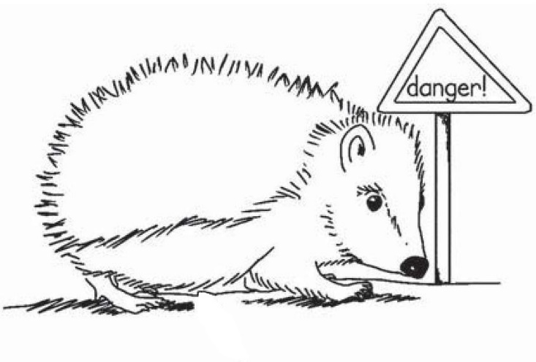
prickly spines
belly

 |  | true | false | not in the text
1 | The hedgehog lives in places where there are plants or grass.
2 | The hedgehog sleeps at night.
3 | The hedgehog likes to drink water.
4 | In winter the hedgehog eats a lot of food.
5 | In winter, the hedgehog’s favourite place for sleeping is under a lot of leaves.
6 | A hedgehog has prickly spines around its nose.
7 | In case of danger a hedgehog runs away.
8 | A dog is a danger for a hedgehog.
9 | A baby hedgehog has hard prickly spines.
10 | At first baby hedgehogs can’t see.

Total: / 10 P.

